Project Proposal:
Project Title:
A Unity Scene which tests the limitations of pathfinder Algorithms in a Chaotic Environment

Research Question
Can D*Lite, A* and Dijkstra’s pathfinding algorithms adapt to changes in chaotic environment using the Unity Engine?
Project Topic

While working on module in Games Technology, I’ve covered a wide variety of different subjects, but I became particularly interested in pathfinders for AI in games. Last year, I worked on a module which required me to implement the A* pathfinding algorithm and apply it to at least 100 enemies in the level. Implementing this helped gain a broad understanding on how an enemy in a game looks for the player. This level was created using a prebuilt custom level design in which the walls were static, so the enemy had an easier time tracking the player’s last possible position. This led me to think about how pathfinders behave if they’re in an environment which is constantly changing at rapid rates over time inside game engines.
Judging from existing devices in the real world, Satnavs (particularly older models used years later) will get confused due to roads created and old ones not existing anymore. However, there are pathfinders which aren’t used in games which adapt to changes in a graph. This is called D* Lite. This pathfinder is not used in games due to most levels being static and simple for the enemy to traverse.

Expected Outputs
This section will show the expected outcome for each pathfinding algorithm implemented into the unity scene. These expected outcomes will be based off information about each pathfinder except for A* (based on findings while working on a past AI module for my course). The expected outputs will be based in a custom-built level which is designed to test the limitations of these pathfinding algorithms.

A* expected outcome:
This pathfinder is commonly used in games because it’s good for knowing the player’s last known position in the level. However, when there’s changes in the map, the pathfinder doesn’t update its path accordingly. This means there’s a chance that the pathfinder will get confused on how to overcome the obstacle which could lead to the pathfinder not completing its path as fast. “The cost determines how difficult the path will be to pass a point on a map (this is determined by current path length. The cost can then take time into account and use the predicted obstacle position to determine whether the path space is impassable.”(Amit, 2011). A* Pathfinding also suffers from conflicting pathways when it’s implemented with multiple agents which could serve as a potential issue when dealing with moving objects such as objects or other agents with the pathfinder implemented.
Dijkstra’s expected outcome:
Dijkstra’s algorithm is the parent of the A* pathfinder which finds the shortest path between the start node and other nodes in the graph. Compared to A*, Dijkstra’s algorithm doesn’t use a heuristics function which prioritises nodes over other nodes. This means that Dijkstra’s looks for all possible paths in an unoptimized order (Jack, 2012). Judging from this, this pathfinder will most likely take the longest to adapt to real-time environment changes which means that the pathfinder will be the least efficient in reaching its goal.
D* Lite expected outcome:
Judging from information provided by gamedev stack exchange user Danny Pflughoeft. D* Lite is primarily used to traverse a single unit through a complicated, changing graph. 2 papers in which he’s linked have been very useful with helping understand how this algorithm works and how it behaves. Judging from reading “D* Lite”, A paper by Sven Koenig and Maxim Likhachev, D*lite is a “Fast replanning method for robot navigation in unknown terrain that implements the same navigation strategies as Focussed Dynamic A* (D*).” (Koenig, Likhachev, unknown). Judging from their results on D*Lite and comparison of using D*Lite without incremental search(A*) and D*Lite in unknown terrain, I can assume that the expected outcome for D*Lite will be relatively successful (with a few failures).

Motivation for the project: Client or Audience.
I think that this project could be important for the gaming industry as it shows both the benefits and drawbacks of each pathfinder implemented into a dynamically changing environment. A* has been implemented by developers in many games. It has been proven effective due to the changes and optimisation over the years and the fact that most AI agents aren’t placed in these changing environments. With the right modification, A* can be changed to fit environment changes with the cost of performance which is a common problem for games today.
On YouTube, there are countless videos of comparing pathfinders with each other where the video shows how the pathfinder calculates the shortest route.
The Unity Engine is a commercial engine used by indie developers and various companies around the world. Various plugins have been developed by dedicated teams to create effective enemy AI for anyone. An example of this is the A* pathfinding project (a plugin for Unity) which lets developers build their own AI using nodes in the Unity Object editor.
This Tech-demo will benefit the Game Dev Industry by practically showing the differences between the 3 chosen pathfinders and check which one is appropriate in a changing game environment. Furthermore, this could shed more light on pathfinders which aren’t typically used by game devs and show ways in which they could be used. Judging from the papers I’ve read and research on all the pathfinders
While pathfinding algorithms have always been compared with each other, It’s only ever been two pathfinders that’s been used for games (A* and Dijkstra). The main goal for this research is to check whether certain pathfinders are more appropriate to use based on the environment they’re provided.

To evaluate whether my solution is successful, I am going to do provide various obstacle levels in which the pathfinder has to find the reach a specified goal provided by the user. Having a wide range of different obstacles gives me a good idea of how they behave. These obstacles will be based off existing ones commonly found in 3d platformers and adventure games since these are the more saturated genres.
Primary Research Plan

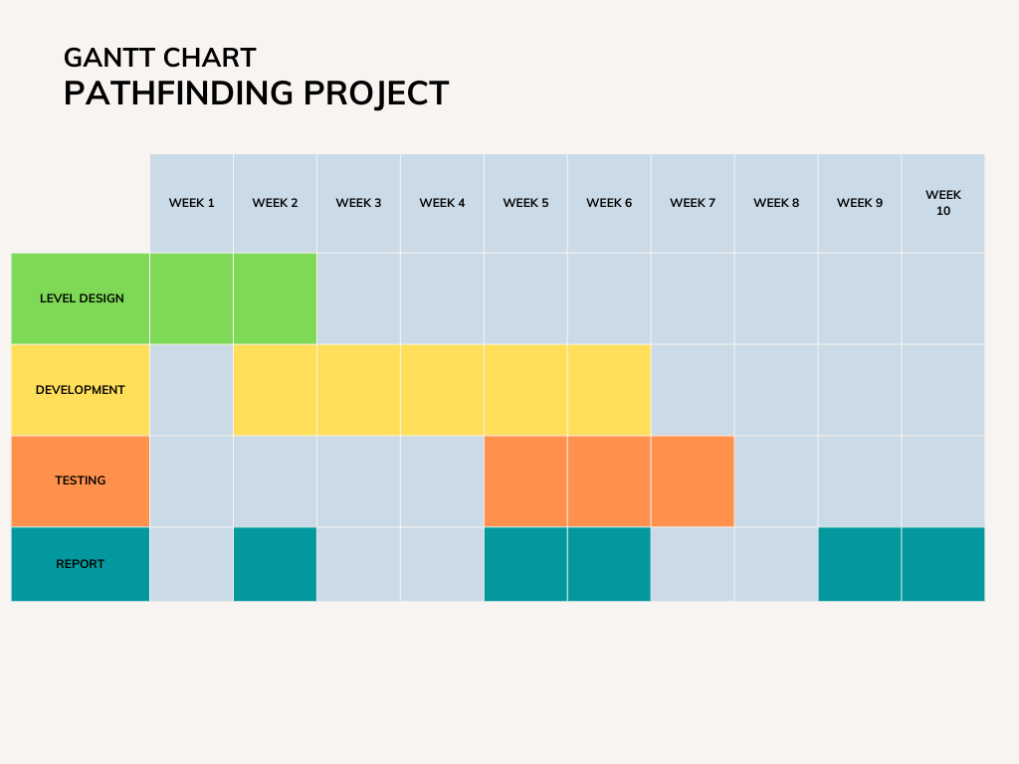
To achieve the results I’m expecting, I’ve laid out a Simple Gantt chart which highlights the areas of creating this project. These involve Level design, Development, Testing and Report. Throughout the project I will also be documenting the process of development and engaging in internal tests which help. Level design is assigned to first 2 weeks because I want to make a custom environment which combines existing obstacle concepts from different titles (Super Mario, Skyrim, Megaman). Having a larger range of obstacles to work from will provide more results in how the pathfinder reacts to these moving obstacles in the scene.
The first week of testing will be dedicated to the results that I find when implementing these algorithms. While the other 2 weeks will be dedicated to user tests which will give a larger range of information.
To make sure this is different; I am going to create an environment which feels familiar to people who play both adventure and platformers. I can create obstacles which match these genres and make the experience interesting for the user testing and the pathfinder algorithms as well.
Finally, the first 3 weeks of development will be dedicated to implementing algorithms while the last two will be dedicated to optimising them for the environment.
- User testing which shows the various results of how pathfinders behave in the changing environment
- Self-testing pathfinders to find out the results once implemented
- 1 week of testing and documenting these results

Literature Review

This project relates to a previous module I took regarding Artificial Intelligence in games. The main goal of this project is to increase my understanding of how pathfinders behave when something is out of their control. While this has been tested by robots and there’s some cases of testing like this within Unity, the difference I’m going to do is to create as much chaos as I can to push the pathfinder to it’s limits. This way I will be able to understand each algorithm’s limitations in a chaotic environment and provide a baseline in which shows what algorithms can do and what they can’t do. In the video created by Benjamin Kramer, he implements A*, LPA* and D* Lite in which the pathfinder reacts to simple changes in the environment (placing walls into the scene which block the initial path). While this shows that pathfinders can update their path based on changes in their environment (which gives me a general idea of how these algorithms react to change), it doesn’t push these pathfinders to their limit, and the total time it takes to reach their specified goal.
Looking at chapter 5 for “Artificial Intelligence in Games”, game developers primarily use the A* pathfinding algorithm as most pathfinding algorithms are a slight improvement from this (Paul Roberts, Chapter5, page6). This will be a great starting point for implementing the other pathfinders I’ve chosen except for Dijkstra’s Algorithm, since A* is the improvement of the Dijkstra’s formula.
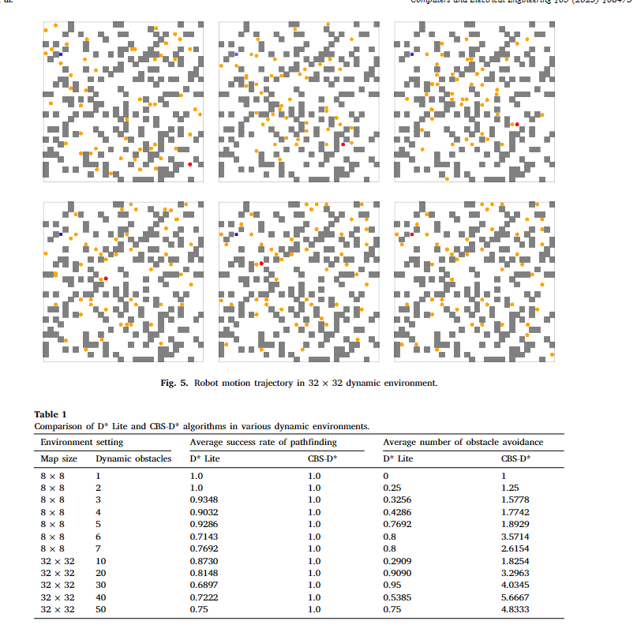
Figure 1: Results from implementing both D* lite and CBS-D* in a dynamic environment. (Jin, J., Zhang, Y., Zhou, Z., Jin, M., Yang, X., & Hu, F. 2022, page 8)
Secondly, looking at a paper called “Conflict-based search for robot path planning in unknown dynamic environments”, a group of academics worked on implementing the D*Lite algorithm for robotics. This robot would be placed in an unknown dynamic environment and would be forced to adapt to the changes this environment presents. This paper builds on D*lite in which the group takes the Manhattan Distance as the heuristic function and increases the incremental search range from 1 neighbour to 3 neighbours which resulted in a 31% improved success rate compared to D* lite which results in a few failures (Abstract, 2022).
Judging from the information provided by the group and a table which highlights the results of the tests they made compared to d*lite, it safe to assume that D* lite is competent in finding its path judging on the grid size and the number of obstacles in the environment. While this has compared d* lite with their optimised version, there is a small gap in their research which I’d like to apply to my work. For example, I’d like to compare the success rate of this algorithm with older pathfinders to see how big of an improvement D* lite has over A* and Dijkstra’s in a chaotic game environment. Also with the graph, its hard to tell whether obstacles they used behave the same. I’d like to know how the pathfinder will behave to different obstacle types which can be achieved in a simulated environment. What if the certain obstacles were traversable for the pathfinder but only for a limited time (such as rotating platforms or a moveable bridge) or traps which activate from time to time. I believe providing different obstacle types (some passable, some not) could alter its success rate and obstacle avoidance rate in a game environment (and an increase of space in which the pathfinders can move).
All the work which has already been implemented has given me the opportunity to find gaps in areas of their work. While both Ben and the group of computer scientists have already created instances in which they test how the pathfinder react to dynamic environments, they both haven’t shown how it could react to multiple obstacle types on a much larger scale. Unlike the group of computer scientists in China, Ben has shown visually what happens when an obstacle is in a way, but he hasn’t shown clear limitations of the pathfinder.
My own research project is important because it takes existing pathfinders (some used in games and some not) and applies them to an environment which may be found in games which highlights the positives and negatives of these pathfinders (total time it takes to reach goal, recalculation time and potential failures). As a result, this will give developers a baseline for what they could do in their own games when it comes to implementing AI in their games. Furthermore, this will build on the work Benjamin Kramer has done in his video by checking both the limitations and efficiency of these pathfinders as well as the checking which pathfinder is the most appropriate under certain circumstances.

References

YouTube. (2019). Dynamic Pathfinding using Lpa*, D* Lite and A* Algorithms. YouTube. Retrieved November 30, 2022, from https://www.youtube.com/watch?v=_sNz1EXZGiQ&t=26s.
DaveDave 21233 silver badges88 bronze badges, D., & BlueRaja - Danny PflughoeftBlueRaja - Danny Pflughoeft 7, D. (2017, May 26). How does D* pathfinding work? Game Development Stack Exchange. Retrieved November 13, 2022, from https://gamedev.stackexchange.com/questions/141663/how-does-d-pathfinding-work
Jack . (2012, October 23). Difference and advantages between Dijkstra & A Star. Stack Overflow. Retrieved November 13, 2022, from https://stackoverflow.com/questions/13031462/difference-and-advantages-between-dijkstra-a-star
Koenig, S., & Likhachev, M. (n.d.). D* lite - idm-lab.org (Page 8). idm-lab. Retrieved November 13, 2022, from http://idm-lab.org/bib/abstracts/papers/aaai02b.pdf

Amit, A. (2011). Dealing With moving obstacles [web log]. Retrieved November 22, 2022, from http://theory.stanford.edu/~amitp/GameProgramming/MovingObstacles.html#recalculating-paths.
Foead, D., Ghifari, A., Kusuma, M. B., Hanafiah, N., & Gunawan, E. (2021, February 19). A Systematic Literature Review of A* Pathfinding. Retrieved November 28, 2022, from https://www.sciencedirect.com/science/article/pii/S1877050921000399
Baoyi, H. (2022). Application of Dijkstra algorithm in finding the shortest path. Retrieved November 29, 2022, from https://iopscience.iop.org/article/10.1088/1742-6596/2181/1/012005.

Jin, J., Zhang, Y., Zhou, Z., Jin, M., Yang, X., & Hu, F. (2022, November 23). Conflict-based search with D* lite algorithm for robot path planning in unknown dynamic environments. Retrieved November 29, 2022, from https://www.sciencedirect.com/science/article/pii/S0045790622006887
.
Roberts, P., & Dent, N. (2022). 5. In Artificial Intelligence in games (pp. 1–6). essay, CRC Press. https://www.taylorfrancis.com/chapters/mono/10.1201/9781003305835-5/pathfinding-paul-roberts?context=ubx&refId=02b9b059-91e6-426b-8566-019d9b558367

